A000-Afr-Burkina Faso-Mask-Mossi Karanga-20th c

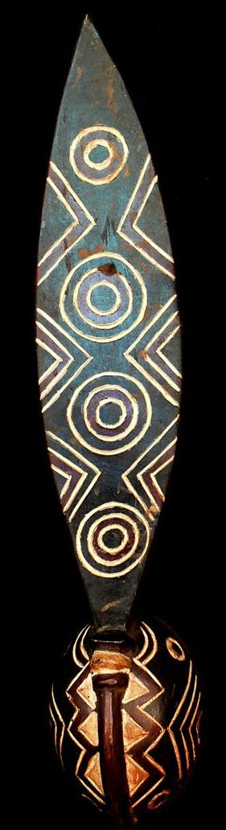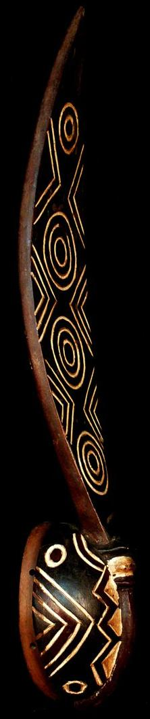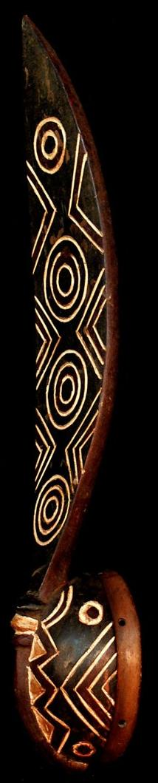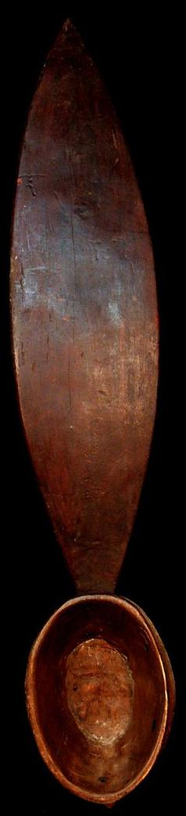

Figs. 1-4. A000-Afr-Burkina Faso-Mask-Mossi Karanga-20th c

Case No.: 6

**Accession No.**

**Formal Label:**

**Display Description:**

Among the Baga carved wood serpents represent the spirit Basonyi, patron of two lower ranks of the male initiation society called to-lom. Manipulated by several men in performance, the headdress is decorated with streamers and supported on a scaffolding covered in palm leaves and cloth. The snake maybe a python-symbol of water and the rainbow whose changing colors are likened to the transformation of young boys into men during initiation.

**LC Classification:** NK1087

**Date or Time Horizon:**

**Geographical Area:**

**Map:**

**GPS coordinates:**

**Cultural Affiliation:**

**Media: wood, kaolin**

**Dimensions:** 27.559 inches

**Weight:** 1.303 pounds

**Condition: original,** Very good condition.

**Provenance:**

**Discussion:**

**References:**